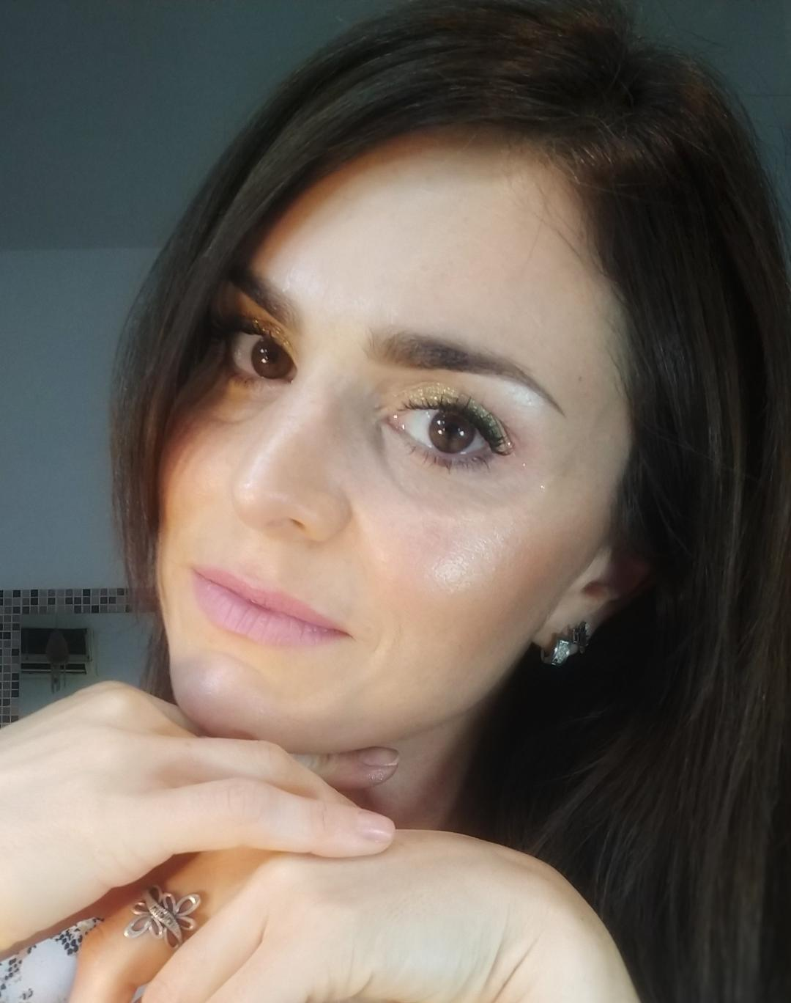
ROMINA CARLA SANTOPOLO
Pinamar
Buenos Aires, Argentina
Mobile: + 54-11 5815 1320
rsantopolo@yahoo.com.ar

ABOUT ME

My name is Romina Santopolo. I am an English Translator specialized in technology. I worked as a Translator Specialist in-house at Lenovo for 10 years, remotely; occasionally in charge of the coordination of the team of translators and dealing with customers and their requests. Today, I am looking for a remote or hybrid position since I'm experienced in this modality and in time management oriented to goals accomplishment, but I’m also open to work daily at the office if the position requires so. At present, I live in Pinamar, a little town in the coast of Argentina, and I work at San Antonio Bilingual School, as a Secretary reporting to the Director in Primary School. This position gave me a lot of experience in attention to detail, customers’ support, dealing with parents and their daily demands, treatment with children in a pedagogic way, and in organization and coordination of tasks as a must.

I’m willing to be trained for all the necessary tools to be learnt for any role.
I believe communication is central to make relations possible and get results. That's why I studied an online course to be a Community Manager through UBA, University of Buenos Aires. Networks and the creation of good content are a plus for any role. I believe that all my knowledge and experience can be really valuable for any company.
I invite you to read my profile and learn more about everything I've done until now!
Thank you,

EDUCATION

English Technical-Scientific and Literary Translator (1998-2004)
Graduated from Superior Language School “Sofía E. Broquen de Spangenberg” (ex John Fitzgerald Kennedy)

PROFESSIONAL ■ Mother tongue: Spanish
PROFILE ■ Working languages: Spanish <> English / English <> Spanish

OTHER LANGUAGES

■ Italian (Intermediate level) graduated from Dante Alighieri Association in 2010.

TRANSLATION EXPERIENCE (in-house remote)

- LENOVO ARGENTINA (July 2006 / October 2016 - remote)
Member of the Translation Team under Marketing Management in Lenovo Argentina, Buenos Aires, giving support to all Lenovo Latin America regions. Technical Translator (English to Spanish / Spanish to English) for various areas: technical (Web, technical specifications, brochures, courses for resellers and technicians), marketing, press releases, financial reports, media and legal documents. Corrections. English translations Q&A. In charge of the coordination of the team replacing the team leader on vacational periods. Constant use of TRADOS software. Personal inputs for the preparation of a Translation Manual inside the company.

TRANSLATION EXPERIENCE (as a Freelancer)

Translations into English and into Spanish in the following areas: Education, accounting, medicine, technical (engineering, shipping, oil and laboratory), marketing, sustainability, ecology, finance, economy, services, IT, psychology, tourism, security, TV scripts.
- References: Paola Medrano 115108 – 2968 / Darío Dombek: 116289-4386

AT PRESENT

- San Antonio Bilingual School Pinamar: 10-2022: Primary School Assistant. General administrative tasks and agenda. Director’s Assistant.

OTHER FREELANCE EXPERIENCES:

- English lessons online for the company E3. Elementary level (07/2022 – 11-2022)
- Translation classes for students at Moron University, corrections of grammar and style in Spanish, transcriptions, voluntary opinion writing for my neighborhood web portal.
- Submission of public translations to my colleague, Certified and Public Translator María Gutiérrez Cabello: 113803-9201
- Voluntary translation for Garrahan Hospital about Wilms Tumor, a type of children cancer, performed under the supervision of Translator Alejandra Rogante and as a final step to get the Translation Degree.
- English Language Teacher for public schools and private institutions.

OTHER WORK EXPERIENCES:

- Fitness classes and entertainment activities at the beach in Pinamar and Carilo, Summer season 2023, for EIPP Public Relations and Bimbo Marketing (01/2023 – 02/2023).
- Makeup Artist since 2007, working at present for social events.
- Personal Trainer and Spinning Instructor, main occupation up to March 2020.

OTHER WORK EXPERIENCE
■ Good Cold S.A. (September 2003 / June 2006)
Assistant to the sales area. Invoice making. Customer service. General administrative and bilingual tasks.

WORKSHOPS AND COURSES

- Community Manager (Online Course) UBA, University of Buenos Aires. Social Media Marketing (May 2022)

- Workshop on Medical Translation dictated by Translator Claudia Tarazona at Superior Language School “Sofía E. Broquen de Spangenberg” (ex John Fitzgerald Kennedy). Program: Diabetes, AIDS and gynecology (October 2003).

- Practical course on TRADOS (Cat tool) dictated by Translator Nicolás Delucchi at Superior Language Institute “Juan Ramón Fernández” (April 2005).

- Workshop on Translation from Spanish into English dictated by Translator Marita Propato at Superior Language Institute “Juan Ramón Fernández” (June 2005).

- Training on the use of Trados SDL 2007 given by the original Provider at Lenovo facilities (December, 2008)

March, 2024

