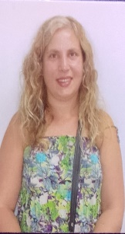

**HAFTEL PAULA**

39 años

Soltera

DNI 30.885.745

CUIL 24-30885745-6  
Ricardo Rojas s/número- Villa de Las Rosas-Traslasierra-Provincia de Córdoba-Argentina

C.P.5885

🕿 11-3088-6586  
🖂paulonchy32@gmail.com

2023

Training in Kobido fascial massage with Japanese technique. ( Certificate with registration)

2018

Certified Massage Therapist at the LACA Institute in Pacheco, Province of Buenos Aires.

2018/Present

I work independently with my own office.

2018/2019

I worked at the Cielo & Tierra Spa in the town of Don Torcuato, Province of Buenos Aires.

--------------------------------------------------------------------------

I specialize in relaxing and decontracting therapeutic massages.

Personalized attention to the patient's needs and ailments in a caring and respectful climate