Romina Carla Santopolo 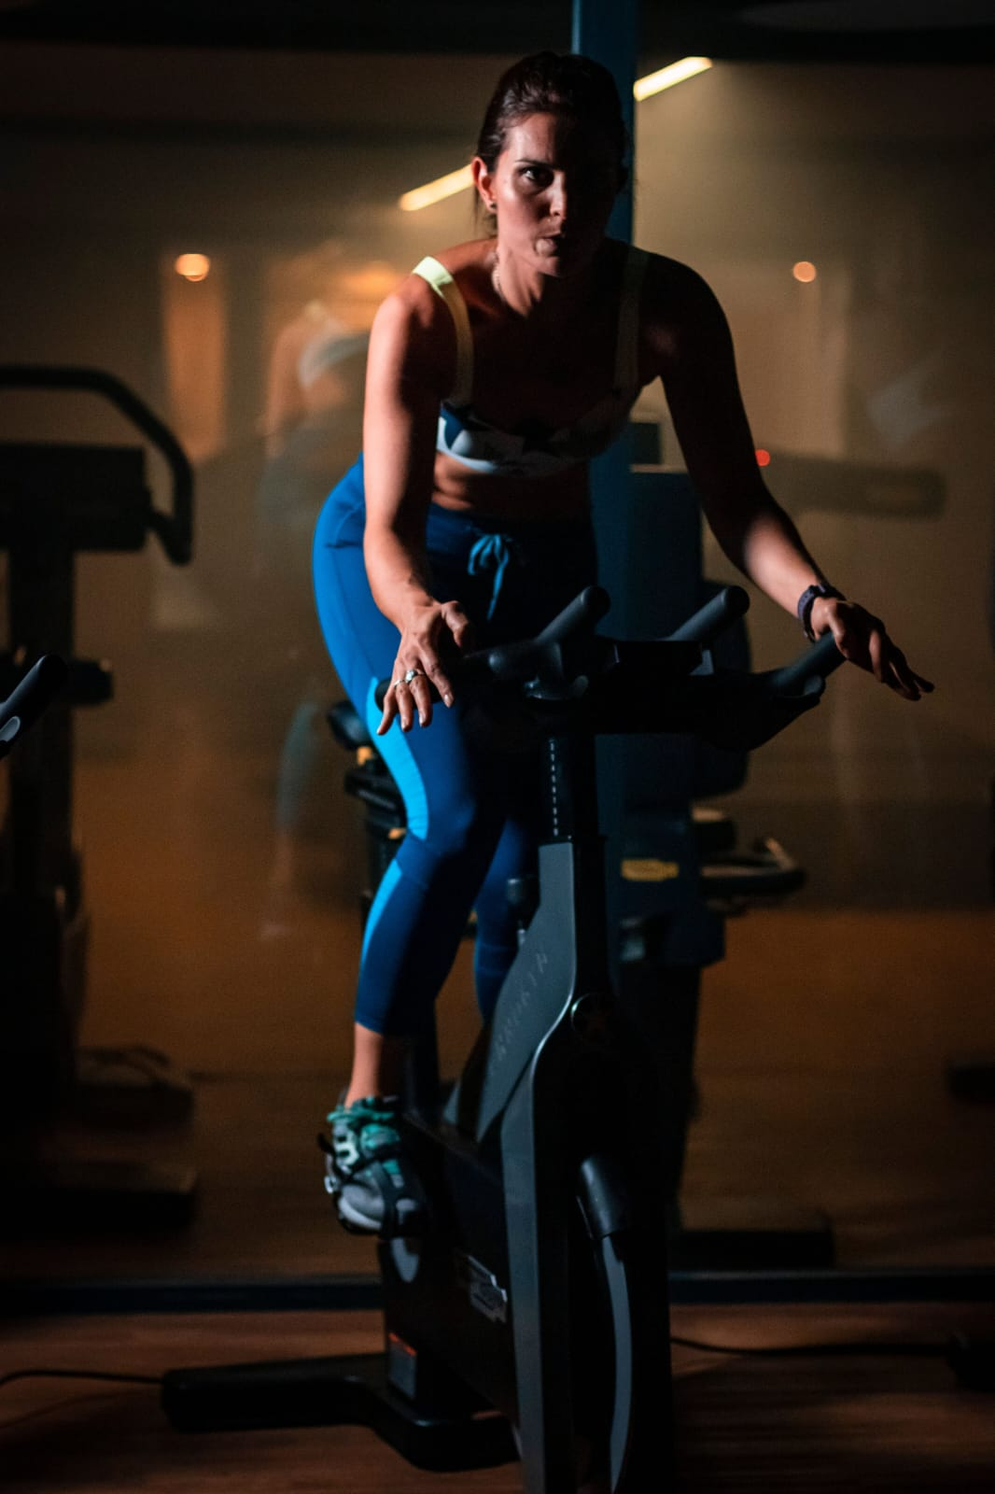
Personal Information | - Location: Villa Luzuriaga, Bs. As.  - Cell Phone N°: 54 11 5815-1320  - Email: rsantopolo@yahoo.com.ar  - Marital Status: Single  - Nationality: Argentinian and Italian  - Age: 44 años
Work Experience | - 05/2024 – At present: Personal Trainer one-on-one at the Street Gym, Villa Luzuriaga.  - 12/2022 – 01/2023: Sport activities at the beach and fitness classes for the brand Bimbo as promotion actions for summer 2023 in Pinamar.  - 12/2021 – 04-2022: Spinning Instructor at Street Gym, Villa Luzuriaga.  - 03/2018 – 03/2020: Personal Trainer on-on-one at the gym. Abs and functional training (In pandemics, online plans and follow-up).  - 03/2020 – 12/2021: Motivation for a healthy lifestyle and food through low calorie cooking sales.  - 03/2017 – 03-2020: Spinning Instructor. Classes at Open Park gym. Model for a summer season campaign for the gym together with Adidas.  - 05/2015 – 2016: Substitute Spinning Instructor at Dashur Fitness and Open Park gyms, Bs. As.  - 02/01/2016 - 02/28/2016: Substitute Spinning Instructor at Multisport gym, Bs. As.  - 08/2015 - 09/2015: Substitute Spinning Instructor at Nexus Factory gym, Bs. As.
Training | - 03/2019: Intensive Training of Italian spinning “Group Cycling” at Open Park gym.  - 07/2019: CPR techniques for Open Park Staff  - 02/2018: Personal Trainer NPC WorldWide Arg  - 09/2017: Spinning Update by Santiago Grande at Open Park gym  - 12-2016: Spinning Update by Santiago Grande at Le Parc gym  - 05-2016: Spinning Update by Santiago Grande at Le Parc gym  - 09-2015: Spinning Update by Santiago Grande at Le Parc gym  - 07-08-2015: Spinning Instructor Course NRG Bike system, by Santiago Grande, in NEF School at Sport Club gym  - 05/2015: Spinning Update by Santiago Grande at Le Parc gym  - 04/2014: Spinning Update by Santiago Grande at Le Parc gym  - 09/2013: Spinning Instructor Course NRG Bike system, by Santiago Grande at 11° International Fitness Convention by Adrián Andreani at Alianza de Clubes gym
Studies | English Technical-Scientific and Literary Translator (1998-2004) with an experience of 10 years of service as an in-house and remote translator for Lenovo Argentina. Translation Team Lead. Freelance Translator. Also, Makeup Artist and Sales Consultant for Natura and Lidherma.
Languages | English: Bilingual. Italian: Basic.  November 2024

