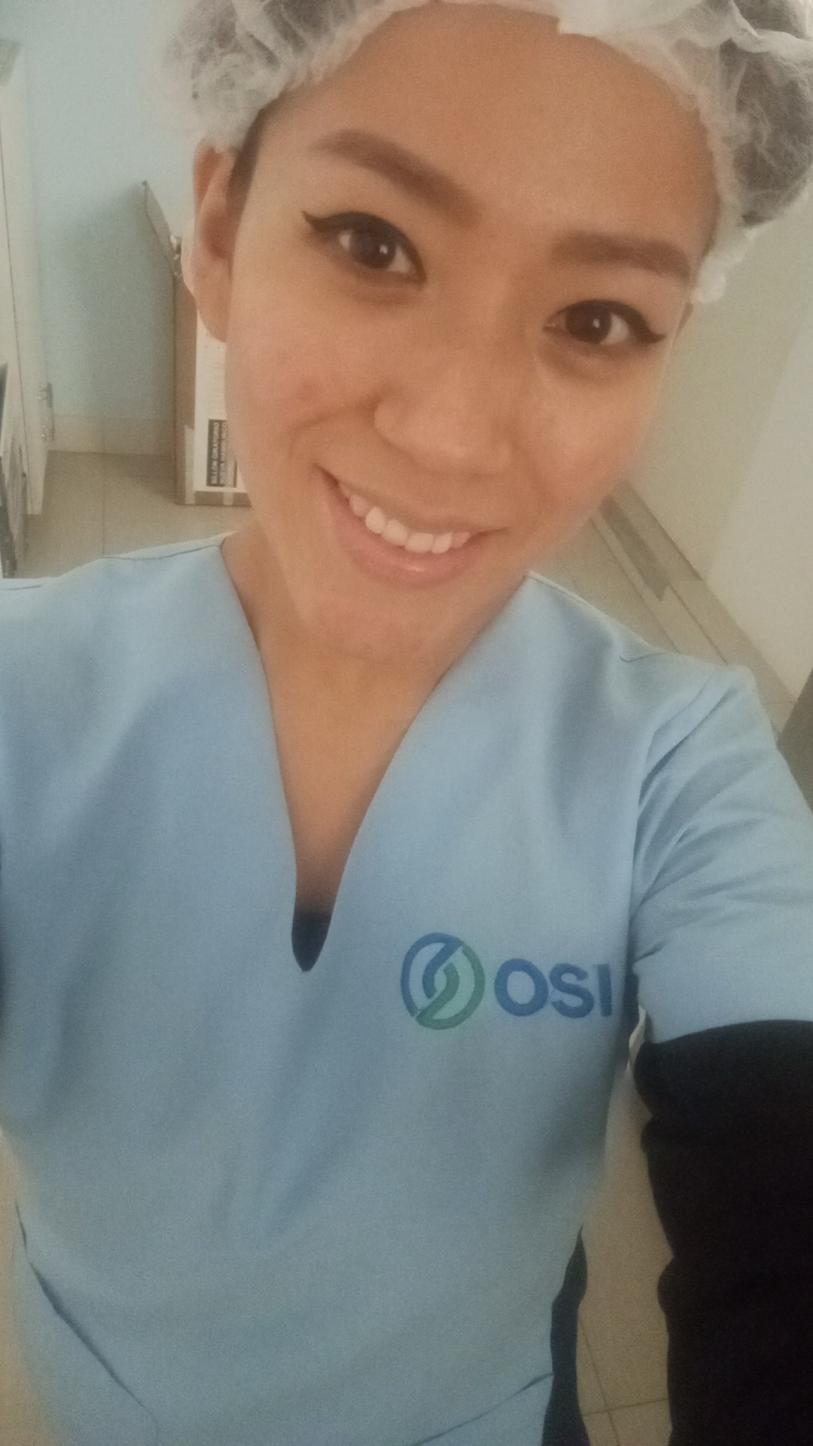
Sector7 grupo3 mazL lote 14 Villa el Salvador
Lima, Lima
(51) 975638438
noeliaromerosalazar38@gmail.com

Yanella Elizabeth Romero Salazar

PROFESSIONAL SUMMARY
Bachelor of Physiotherapy, Specialist in Massage Therapy with experience in cosmetic treatments interested in a job in a company where I can develop my acquired knowledge and with the ability to acquire new learning. Excellent verbal communication and customer service skills. Qualified to offer a variety of body, facial and massage treatments. Positive, enthusiastic and dynamic, eager to improve and continue filling myself with knowledge.

EXPERIENCE

Idriss spa, Miraflores — Massagist
02/2015 - 03/2016

- Cleaning the massage rooms and preparing them for the next patients.
- I worked with several patients a week performing different types of therapeutic massages, sports massage, relaxing, decontracting, Hawaiian massage, hot stone massage, hair removal with cream.
- I performed express facial cleansing with products for combination skin, facial masks, etc.
- Body scrubs
- Leave everything clean and arranged for the morning shift.

Essalud en linea, Jesús María — Teleoperator
03/2017 - 07/2017

- Received calls for medical consultations in different specialties.
- Provided information about available slots, day and time of certain specialties.
- Directed patients to their specific hospital locations and provided referrals.
- We had to know how to reach the patient and provide them with support in case they had any problems with the management.
- Listen to their ailments and above all be patient and communicative with the patient.
- We had a certain telephone attention time and we had to be tolerant and know how to explain to the patient as briefly as possible.

Centro de salud alternativa OSI
Physiotherapist 10/2021 – 05/2023

- Perform rehabilitation therapies in treatments such as sprains, postural issues, scoliosis, pain, fractures, post-operative, neurological issues such as facial paralysis, etc.
- Alternative therapy such as acupuncture for anxiety problems, insomnia, fertility problems for both men and women, erectile dysfunction problems, pregnancies, etc.
- Programming of therapies for each patient as well as monitoring them.
- Perform neurological therapies in facial paralysis, people with hemiplegia, muscular dystrophy.
- Shock wave therapy for heel spurs and plantar fasciitis that worked very well for them.
- Cleaning of my environments and equipment such as therapeutic current, ultrasound, infrared, therapeutic laser, magnet and shock wave. Leave everything arranged for the next shift in the morning.

DEPILIFE
Epilator 06/2023 – 11/2023
- I worked as an epilator with Laser Soprano Titanium.
- Provided induction of benefits and contraindications to the patient.
- The patient already had to come shaved, he was not helped during the session unless it was an area that was difficult to reach.
- The patient was instructed in the position to be in to begin the hair removal.
- Always put safety glasses on both the patient and yourself and if there is a companion as well.
- The table is cleaned and disinfected after each patient, as is the laser head used.
- Everything was left clean, arranged and supplied for the next morning.
- A record was filled out for each patient where the most essential data was noted, whether the patient had any illness, skin allergy, any skin problem, etc.
- We had constant training.
- We did not charge or provide information on promotions or costs for each area.

Depilzone
Body treatment specialist / Cosmiatrician 25/11/2023 – 04/04/2024

- Cosmiatric aesthetic center where I scheduled, canceled or rescheduled patient appointments.
- Performed the induction of each body treatment, prices and promotions of each of them.
- Physical evaluation of each person for the next body treatment.
- Performed body treatments to reduce measurements, buttock increase with peptones, and laser hair removal in different parts of the body.
- Performing facial treatments such as deep facial cleansing with Hydrofacial, diamond tip, dermapen, etc.
- Carrying out treatments to reduce measurements in the abdomen, back, arms or legs with devices such as lipolaser, ultra cavitation or radiofrequency (according to evaluation for each person), fit sculp (for muscle toning) and for buttocks the use of vaccine therapy, fit sculp, Russian waves.
- Filling out the closing book per day, cash closing and POS.
- Cleaning of each room, leaving everything stocked, with syringes and needles, cleaning of equipment, etc.
- Filling and explanation of each point of the medical history to the patient as an explanation of each point of the consent prior to treatment.

Centro estético La Bonne Vie
Cosmiatrician 20/05/2024 – 18/11/2024

- In charge of evaluating each patient according to the treatment desired, whether in body treatments, laser hair removal or facial treatments.
- Personalized attention to each patient, induction of each treatment to choose.
- Performing alexandrite laser hair removal with Motus AX, explanation of the treatment, pre and post hair removal recommendation.
- Performing body treatments to reduce measurements, sagging and cellulite with the Onda Coolwaves machine.
- Induction of each procedure and the same machine.
- Taking measurements and photos at the beginning and end of the treatment.
- Facial treatment with the Hydracial machine and conventional facial cleansing according to the skin type of each patient, diamond tip, high frequency, electroporator, facial radiofrequency, vaporizer and LED light mask.
- Relaxing, stress-relieving massages with hot compresses, hot stones, shiatzu on key points.
- Evaluation of the skin and induction of the procedure to be performed.

EDUCATION

Universidad Alas Peruanas, Breña — Medical Technology in Physical therapy and rehabilitation
03/2013 - 08/2018

Top English Center – English
05/09/2023 – 25/02/2025

SKILLS

- Actitud positiva
- Participativa
- Positive attitude
- Participatory
- Honest and responsible
- Empathic
- Communicative
- Very kind and sincere.
- Proactive
- Teamwork

