CURRICULUM VITAE

PERSONAL INFORMATION

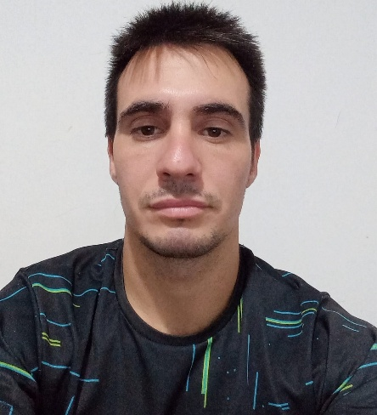First and Last Name: Pablo Ezequiel Rolla

DNI: 38.047.071

Date of Birth: 04/20/1995

Marital Status: Single

Address: Billinghurst 2129 1st Street (Federal City)

Cell Phone: 02478-15-449072

Email: [pabloezrolla_95@hotmail.com](mailto:pabloezrolla_95@hotmail.com)

• **ACADEMIC TRAINING**

- HIGHER EDUCATION PROFESSOR IN PHYSICAL EDUCATION

"Dr. Enrique Romero Brest Higher Institute of Physical Education No. 1"

- LIFEGUARD DEGREE IN THE PROFESSIONAL WATER RESCUE TEAM (EPSA)

- BACHELOR'S DEGREE IN NATURAL SCIENCES.

"Domingo Fidel Sarmiento" Secondary School No. 2 (Capitán Sarmiento)

- HIGHER TECHNICIAN IN PHYSICAL ACTIVITY AND SPORTS PHYSICAL PREPARATION (ISDE)

• **LANGUAGES**

- Fluency in English. Advanced English Course "Cambridge Institute of English Culture", December 2012

• **COMPUTER SCIENCE**

- Intermediate proficiency in Microsoft Office and Excel

• **WORK EXPERIENCE**

- General fitness trainer (team and individual sports)

- Personal trainer (specializing in functional training and personalized training for different ages)

● Sheraton Hotel (2024)

- Lifeguard role and pool maintenance

● "Colegio Rio de la Plata" (2022/2023)

- Participation in extracurricular sports workshops as a soccer teacher (2023)

- Member of the teaching staff at the community center (2022)

● City Government Summer Camp 2021/2025

- Member of the lifeguard staff at the "Polideportivo Pomar"

● Summer Camp 2020

- Member of the teaching staff of teachers and assistants who participated in the summer camp within the "CLUB DE AMIGOS" complex, serving as a summer camp assistant.

● Sportkinesis Versailles Hydrotherapy (2019)

- Serving as a teacher for children and adolescents with disabilities

* Youth Olympic Games, October 2018.

- Voluntary participation as an activity guide. My role consisted of managing the different groups formed by visiting schools, taking them to the day's activities.

● Electromedik, March 2016 – March 2018.

- Member of the production team, handling orthopedic devices and assembling orders for hospitals and clients.

- Collaboration with a family-run agricultural business, dedicated to planting and harvesting crops in the summer.

• OTHER INFORMATION

- Driver's license. Classes: A.1.3.-B.2

- Own mobility

- CABA lifeguard revalidation