DARIELIS CAROLINAVELÁSQUEZ AREVALO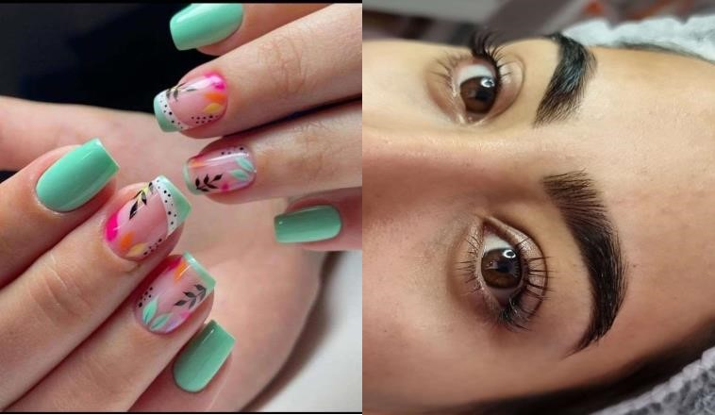

Beautician/ manicurist

COURSES

Academy: Sebastián

CONTACT

Date/ Year: 01/15/2020 - 03/16/2020

PHONE:

Educator: Carlos Ortega Ovando

+569 51502362

Certification: Manicurist

Academy: K Maia Amor de Cejas

Address: Patricio Lynch￼   ￼ ￼

Date/ Year: 04/01/2021 - 04/30/2021

Educator: Kelly Maia (comprehensive beautician)

Rut: 27.230.324-K

Certification: Eyebrow Design, eyelash lifting, Egyptian waxing

MAIL EMAIL:

Academy: K Maia Amor de Cejas

Darieliscarolinav2017@gmail.com

Date/Year: 01/05/2021 - 31/05/2021

Educator: Kelly Maia (comprehensive beautician)

Certificate: Body Waxing, Full Brazil

Academy: MANICURISTAS PRO

Date/Year: 72H/ 06 / 2021

Educator: María Rafaela Contreras (Master Educator Mpro Fanny

Salinas (CEO MANICURISTAS PRO & International Master Educator) Certificate: Perfection of structure in acrylic- tips

Academy: MANICURISTAS PRO

Date/Year: 02/ 07/ 2022

Educator: María Rafaela Contreras (Master Mpro) Fanny Salinas

(CEO PRO MANICURISTS & International Master) Certificate: Technical Work with Lathe

Academy: SUPREMI (Professional Nail Systems)

Date/Year: Days (23/24/25) - Month 05/ Year 2022

Educator: Fanny Salinas (CEO PRO MANICURISTS & International Master)

Certificate: Improvement in nail systems (Polygel, Gel, Acrylic)

Academy: Fundación del Carmen

Date/Year: 20011/ 2022

Educator: Valeria Figueroa Acevedo (Comprehensive Cosmetologist) Certificate: Cosmetologist I

Academy: Fundación del Carmen

Date/Year.• 350h / 2020

Educator: Valeria Figueroa Acevedo (Comprehensive Cosmetologist) Certificate: Cosmetologist 11 and 111

SKILLS￼

Teamwork

Pro Active

Responsibility

Disposition

Good customer communication

WORK EXPERIENCE

Company: Beauty Salon (BELEN)

Location: Futrono Year: 2019/ 2020 Performance: Manicurist

Company: Peluquería NINO

Location: Valdivia Year: 2020 2021 Performance: Manicurist

Company: Señorita Brasil

Location: Valdivia Year: 2021 2023

Performance: Comprehensive Esthetician, Manicurist

Company: Glam&co

Location: Valdivia Year 2023/2024

Performance: Comprehensive Esthetician, Manicurist

Company: En la VIP

Location: Valdivia Year: 2024

Performance: Comprehensive Esthetician

Company: Yaniz

Location: Valdivia Year: 2024

Performance: Comprehensive Esthetician Currently